UNIT IV

SPECIAL ICs

PART-A

1.Draw the pin diagram of IC 555 timer.(Nov/Dec-18)
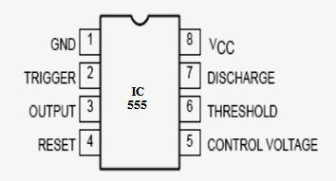

2. In the monostable multivibrator, R= 100 KΩ and the time delay T= 100ms.Calculate the value of C.

Time delay of 555 monostable multivibrator, T=1.1 RC.
∴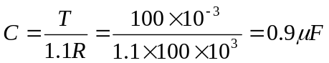
∴C = 0.9μF

- What are the applications of 555 Timer ?

  - Astablemultivibrator

  - Monostablemultivibrator

  - Missing pulse detector

  - Linear ramp generator

  - Frequency divider

  - Pulse width modulation

  - FSK generator

  - Pulse position modulator

  - Schmitt trigger
- Draw the block diagram of PLL.(AU-Nov/Dec-2017)

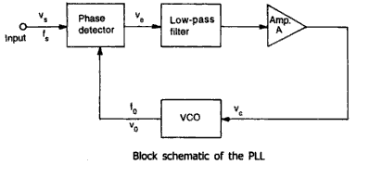
- .Give the applications of 555-timer Astablemultivibrator. (April/May-11)

The applications of 555-timer Astablemultivibrator are,

- Square wave generator

- Voltage Controlled Oscillator (VCO)

- FSK Generator

- Schmitt trigger.

- Define VCO and write the features.

A voltage controlled oscillator is an oscillator circuit in which the frequency of oscillations can be controlled by an externally applied voltage.

- List the features of IC 566 VCO. (April/May-15)

  - Wide supply voltage range 10 V to 24 V

  - Very linear modulation characteristics

  - High temperature stability

  - Excellent power supply rejection

  - 10 to 1 frequency range with fixed C1

  - The frequency can be controlled by means of current, voltage, resistor, or capacitor.
- Why voltage controlled oscillator is called voltage to frequency converter?

A voltage controlled oscillator (VCO) is an oscillator circuit in which the frequency of oscillations can be controlled an externally applied voltage. The VCO provides a linear relationship between the applied voltage and the oscillation frequency. As voltage controls the frequency, it is called voltage controlled oscillator.

- In what way VCO is differ from other oscillator. (May/June-12)

An oscillator is circuit that generates the frequency output of fixed frequency. On the other hand, a voltage controlled oscillator (VCO) is an oscillator circuit in which the frequency of oscillations can be controlled by an externally applied voltage.

10.Draw the block diagram of PLL. (Nov/Dec-14) (April/May-17)
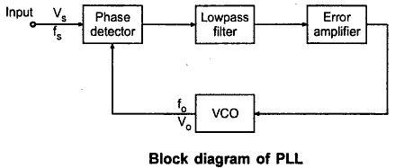

11.What do you mean by PLL?

A PLL is a basically a closed loop system designed to lock output frequency and phase to the frequency and phase of an input signal.

- What are the essential parts of PLL? (Nov/Dec-13)

- Phase detector

- Low pass filter

- Error amplifier

- Voltage controlled oscillator.

13.List the applications of 565 PLL. (Nov/Dec-19)

  - Frequency multiplier

  - Frequency synthesizer

  - FM demodulator

  - Frequency shift keying demodulator

  - AM detection

  - Frequency translation

14.What is VCO? (AU-April/May 2017)

VCO is the Voltage controlled oscillator. It is a free running multivibrator operating at a set frequency f₀ called the free running frequency. This frequency is determined by an external timing capacitor and an external resistor. It can be shifted to either side by applying a dc control voltage to the appropriate terminal of the IC.

15. Define lock range and capture range of PLL? (Nov/Dec-15) (May/June16,18)
Lock Range
When PLL is in lock, it can trap frequency changes in the incoming signal. The range of frequencies over which the PLL can maintain lock with the incoming signal is called as lock range.

Capture Range

The range of frequencies over which the PLL can acquire lock with the input

signal is called as capture range.

- Name few applications of analog multiplier. (AU-CBE-Nov/Dec-2017)

Analog multiplier finds application in
- Signal modulation / demodulation.
- CRT distortion compensation
- Frequency doubling / shifting.
- Transducer response linearization
- Phase angle detection.

- Draw the block diagrammatic representation of a frequency multiplier using PLL? (Nov/Dec-14, 16)
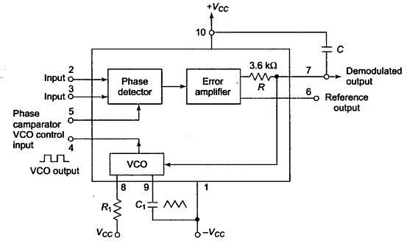

PART-B

1. Explain the working of a 555 Timer circuit. (Nov/Dec-19) (Apr/May-18)(Apr/May-17)

- Timer is a highly stable device for generating accurate time delay or oscillation. Signe tics corporation introduced this device as the NE555/SE555 and it is available in two package styles,8-pin circular style,TO-99 can or 8-pin mini DIP or as 14-pin DIP.
- A single timer can produce time delay ranging from microseconds to few hours. It can be used with supply voltage in the range of +5V to +18V and can drive load up to 200mA.

PIN DIAGRAM:
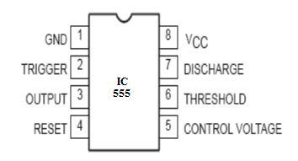

- Referring to the above figure, three 5k internal resistors acts as voltage divider, providing bias voltage of ²₃V_{CC}  to the upper comparator (UC) and ¹₃V_{CC}  to the lower comparator (LC), where V_{CC} is the supply voltage.

- Since these two voltages fix the necessary comparator threshold voltage, they also aid in determining the timing interval. It is possible to vary it electronically too, by applying the modulating voltage to the control voltage input terminal (pin 5).

- In applications where no such modulation is needed, it is recommended by manufacturers that a capacitor (0.01F) be connected between control voltage terminal (Pin 5) and ground to by-pass noise or ripple from the power supply.

- In the standby state (stable) state, the output Q of the control flip-flop (FF) is HIGH.

This makes the output LOW because of power amplifier which is basically an inverter.

- A negative going trigger pulse is applied to pin 2 and should have its dc level greater than the threshold level of the lower comparator i.e., ¹₃ V_{CC} 

FUNCTIONAL DIAGRAM:
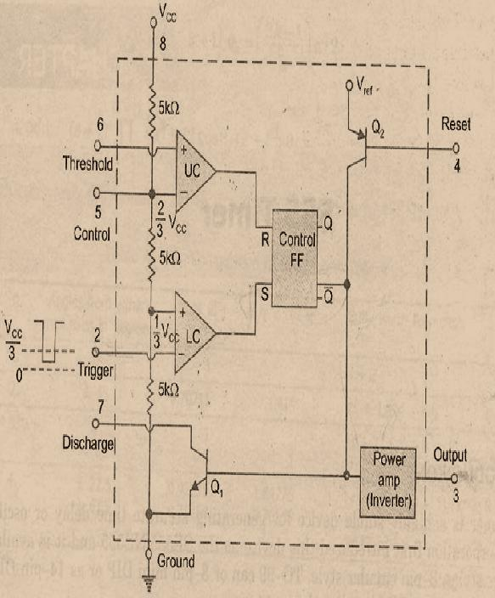

- At the negative going edge of the trigger pulse, as the trigger passes through ¹₃V_{CC} , the output of the lower comparator goes HIGH and gets the flip-flop


- During the positive excursion, when the threshold voltage at pin 6 passes through ²₃V_{CC} , the output of the upper comparator goes HIGH and thus resets the flip-flop

- The reset input (pin 4) provides a mechanism to reset he F/F in a manner which overrides the effect of any instruction coming to F/F from lower comparator.This overriding reset is effective when the reset input is less than about 0.4V.
- When this reset is not used, it is returned to V_{CC.} The transistor Q₂ serves as buffer to isolate the reset input from F/F and transistor Q_{1.} The transistor Q₂ is driven by V_{ref} obtained from supply voltage V_{CC.}

APPLICATIONS:

    - Pulse generator, Ramp generator.

    - Mono-shot multivibrator

    - Burglar alarm, Traffic light control, Voltage monitor.

  - Draw the block diagram of 566 voltage controlled oscillator (VCO) and explain its briefly .(April/May19)(April/May-18),(Nov/Dec-18) (May/June16).

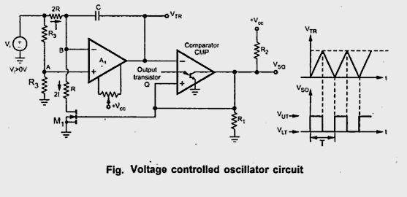

A voltage controlled oscillator is a oscillator ckt in which the frequency of oscillation is controlled by externally applied voltage called control voltage.
- This circuit is also called voltage to frequency converter

- From block diagram, timing capacitor, C_{T} is changed and discharged linearly by a constant current source.

- The current value can be controlled by either by changing the control voltage given at the modulating input (pin 5) or by changing the timing resistor (R_{T}) connected to pin 6.
- If control voltage at pin 5 in increased, the voltage at pin 6 also increases resulting in less voltage across R_{T} and thereby decreasing the changing current.

The voltage across capacitor C_{T} is applied to (-) terminal of schmitt trigger (A _{z} )

via buffer (A₁)
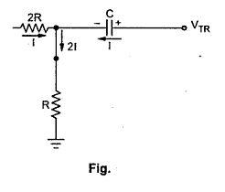

The output of schemit trigger is designed to swing between 0.5Vcc and Vcc . The voltage at (+) terminal of schemit trigger swings between 0.25 Vcc and 0.5 Vcc.

- When capacitor voltage exceeds 0.5 Vcc, output of schemitt trigger goes LOW (0.5Vcc) and capacitor starts discharging.
- When capacitor voltage discharges to 0.25 Vcc, the output of Schmitt trigger goes H/GH (+Vcc)
- Since source and sink currents are equal, capacitor charging and discharging time are equal so the output at pin 3 is a triangular waveform.

- The square wave output of Schmitt trigger is inverted by A₃ and available at pin 3

Typical Connection Diagram
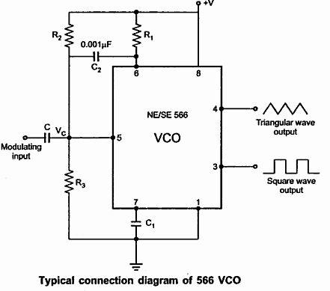

Total voltage on capacitor changes from 0.25. The capacitor changes with constant current source.
The control voltage (v₁) is varied by voltage divider R₁&R₂ . With no modulating signal if pin 5 is biased at (7/8 V_{cc}), the frequency of oscillation is

f ₀ |  | 0.25
f ₀ |  | R_{T} C _{T}

Voltage to freque3ncyconversion factor K _{v} is defined as

K _{V} |  |  f ₀ |  | 8 . f ₀
K _{V} |  |  V _{c} |  | ^{V} cc
Where

f₁ f ₀ , frequency shift produced by change in modulating voltage V_{c}

APPLICATIONS:

Signal generation, FM modulation, FSK demodulator. Frequency multipliers.

5. With block diagram discuss the principle of operation of NE 565 PLL circuit.

(April/May-15) (April/May-17)(Nov/Dec-19)

IC 565 is available in 14 pin DIP package and 10-pin metal can package.

The block diagram of IC 565 PLL consists of phase detector, amplifier LPF and a VCO.

BLOCK DIAGRAM OF IC 565 PLL

- As shown in block diagram, the PLL is not internally connected so output of VCO (pin 4) and phase comparator input (pin 5) are connected externally.

- The centre frequency of PLL is determined free running frequency of VCO given by
^{f} 0 |  | 1.2 | Hz  | 0.3 | Hz
^{f} 0 |  | R₁C₁ | Hz  |  | Hz
 |  | R₁C₁ |  | ^{R}1^{C}1

where R₁& C₁ are external components connected to pi 8 and 9 respectively.

- The value of R₁ and C₁ are adjusted such that the free running frequency will be at the center of input frequency range.
- The capacitor C₂ controlled between pin 7 and 10 appears as a portion of loop filter. Its value should be large to eliminate oscillations in VCO output.

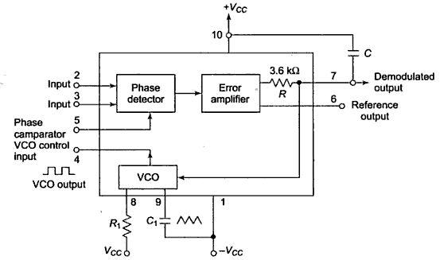

PIN DIAGRAM;
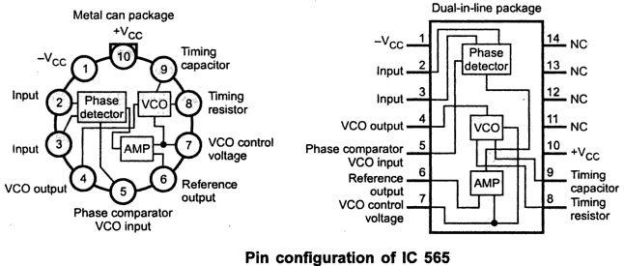

- The lock range increases with an increase in input voltage but decreases with increase in supply voltage.
- The two inputs, to phase detector (pin 2 and 3) allows direct coupling of an input signal, provided there is no dc voltage difference between the pins

- A reference voltage at pin 6 is approximately equal to dc. Voltage of demodulated output at pin 7
- This reference voltage may be used as comparator input in FSK demodulator

application.

6.Explain the working (or) operation of a basic PLL.(Nov/Dec 2019)

A phase Locked Loop (PLL) is a frequency selective circuit designed to synchronise (lock) with an incoming signal and maintain the synchronization (locked state) inspite of noise or variations in the input signals. The basic PLL system comprises a phase detector, Loop filter, error amplifier and voltage controlled oscillator (VCO)
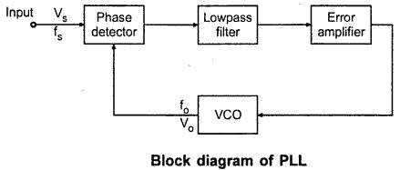

- The phase detector compares the phase of input frequency (f _{s}) and feedback frequency (f₀) and generates output signal which is a function of difference between the two phase values.

- The output of phase detector is filtered to remove the high frequency noise from d.c voltage
- The output of the filter, called the error voltage or control voltage for VCO is fed into the VCO.

When control voltage is zero, VCO is in free –running mode and its output is called center frequency, f₀

- Non – zero control voltage results in a shift in VCO frequency from f₀ to a frequency f , given by
f  f₀  K_{v}V_{c}

where

K_{V} Voltage to frequency transfer coefficient of VCO.

- The error voltage, V_{E} forces the VCO to change its output frequency in the direction that reduces the difference between the i/p and o/p frequency of VCO.
- This action is called capture process it continues till the output frequency of

VCO is same as i/p signal frequency i.e f_{s}f₀
When f_{s} = f₀ , the system is said to be locked. In locked condition, phase detector generates a d.c signal which is required to shift the output frequency of VCO from centre frequency to input frequency.

- Once locked, PLL tracks the frequency changes of input signal. Thus PLL

goes through three stages of operation free running, capture and lock in or tracking range.
TRANSFER CHARACTERISTICS OF PLL:

The vertical axis is the error voltage and horizontal axis is the input

frequency varied over broad frequency range.

- As input frequency is increased, the PLL responds only when frequency

reaches f₁, which is the lower edge of the capture range.

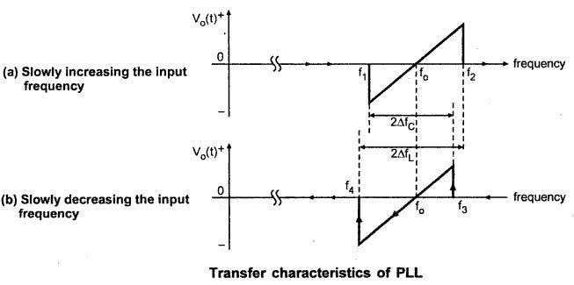

Now PLL locks the input frequency and causes negative jump of error voltage is shift the output frequency of VCO.

- As input frequency is further increased, at f_{s} = f₀, the error voltage is zero.

- If f _{s} is increased f₂ which is the upper edge of lock range.

- After that PLL loses lock and error voltage drops to zero. If input frequency is reduced slowly the cycle repeats as shown in fig. (ii)

- Now PLL recaptures at f₃ and tracks it up to f₄ where f₃ is the upper edge of capture range and f₄ is lower edge of lock range.

- The frequency range between f₁ and f₃ is called capture range (2f_{c}) and

frequency range between f₂ and f₄ is called lock or tracking range (2f_{L}) generally lock range is greater than capture range.

- Explain how frequency multiplication is done using PLL. (April/May-19))(Nov/Dec-19)
A divide by N network is inserted between the VCO output and the phase

comparator input. In the locked state, the VCO output frequency fo is given by,

fo = N f_{s}

The multiplication factor can be obtained by selecting a proper scaling factor N of the counter.
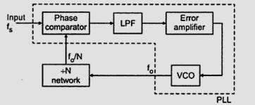

Frequency multiplication can also be obtained by using PLL in its harmonic locking mode. If the input signal is rich in harmonics e.g. square wave, pulse train etc., then VCO can be directly locked to the n-th harmonic of the input signal without connecting any frequency divider in between. However, as the amplitude of the higher order harmonics becomes less, effective locking may lock take place for high values of n.Typically n kept less than 10.

The circuit of figure can also be used for frequency division. Since the VCO output (a square wave) is rich in harmonics, it is possible to lock the m-th harmonic of the VCO output with the input signal f_{s}. the output fo of VCO is now given by,

fo = (f_{s}/m)

The typical connection for frequency multiplier figure shows LM 565 IC used as a frequency multiplier circuit. The IC 7490 is a 4 bit binary counter. It is configured as a divide by 10 circuit.
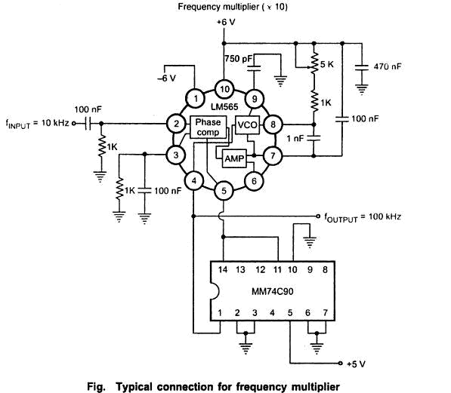

- Explain FM Demodulation using PLL (or) Explain how PLL is working as a FM detector.
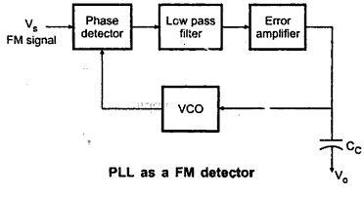

- The three main components of the FM detection system are voltage controlled oscillator (VCO) , Loop filter and phase detector.

- In most PLL ICS, VCO and phase comparator are on chip and external terminals are provided for connecting loop filter.

- Assume that input signal contains modulated angel function  _{i} (t), which represents some intelligence signal to be extracted by PLL.
- This input signal and output of VCO are both applied as inputs to the phase comparator.
- Sine function is assumed for input and cosine function for VCO output 90⁰ phase difference is assumed between these two inputs of phase detector.
- Now the input and VCO output are sinusoids of frequency _{c}, but with phase difference of 90º. The phase comparator and lop filter outputs . Thus loop is locked in equilibrium state.
- Next assume some intelligence signal  _{i} t appear in input. Thus the two

inputs of phase comparator have different frequencies and phases and an error voltage v_{e} t appears.

- This voltage is smoothed by loop filter to produce v_{e} t  and then applied as VCO input.

- This control signal causes the VCO frequency to shift in a direction that causes VCO frequency to match that of input, thus reducing loop “error” towards zero.

- Feedback structure of the loop forces VCO to generate same FM signal that was generated back at the transmitter.
- Thus VC control voltage v_{e} t  assume the same form as at the transmitter and the intelligence“ has been extracted.

- This loop coupled with FM process offers significant reduction in noise, so a “clean” version of modulating signal is extracted.
- Explain AM detection using PLL (or) Explain AM demodulation using PLL .

  - The PLL can be used an coherent detector for demodulating AM signal.
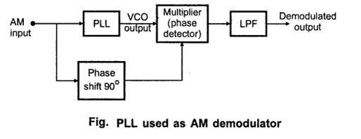

BLOCK DIAGRAM OF AM DETECTOR
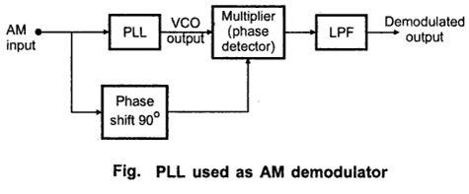
  - The PLL locks with carrier of AM input signal so that output of VCO has same frequency as that of carrier but no amplitude modulation.
  - When the VCO signal is multiplied with AM signal, the demodulated output is obtained after filtering the high frequency components using a LPF.
  - The VCO output signal is 90º out of phase with input signal under lock condition. So 90º phase shift is repaired before applying the input signal to the multiplier.
  - The average value of ^{V}0 ^{t} is directly proportional to the amplitude of the input signal.

  - Since PLL responds only to carrier frequency vary close to VCO frequency the phase locked AM detector provides high degree of selectivity.
  - Also this system provider high degree of noise immunity.

Write a short note on analog multiplier. (AU-Nov/Dec- 2019) (AU-Apr/May- 2018)

Analog Multipliers:
- A multiplier produces an output V0 , which is proportional to the product of two inputs Vx and Vy divided by the reference voltage V_{ref.} normally the reference voltage is set at 10 volts, so,
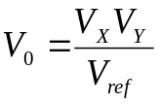
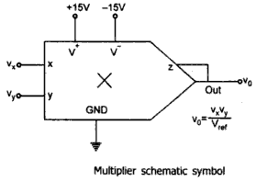
- Normally reference voltage is internally set at 10 volts,so
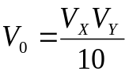

- That is, V0 = K VxVy
Where K is the scaling factor.
- As long as,
V_{X} < V_{ref}
V_{Y} < V_{ref} the output of the multiplier will not saturate.
- If both the inputs are positive the circuit is said to be a one quadrant multiplier. If one of the inputs is held positive and the other one is allowed to swing between positive and negative it is called as two quadrant multiplier.
- If both the inputs may be either positive of negative, the IC is called a four quadrant multiplier.

- Applications of analog multiplier
- Frequency doubling.
- Frequency shifting.
- Phase angle detection.
- Squaring.

- Multiplication.
- Division.
- Waveform generation.
- There are various methods available for performing analog multiplication.
Such techniques, namely,
- Logarithmic summing technique
- Pulse height/width modulation Technique
- Variable trans conductance Technique
- Multiplication using Gilbert cell and
- Multiplication using variable transconductance technique.
- Classification of multiplier.
- One- quadrant multiplier.
- Two- quadrant multiplier.
- Three - quadrant multiplier.
- Four- quadrant multiplier.
- If both inputs are positive, the IC is said to be a one quadrant multiplier.
- A two quadrant multiplier will function properly if one input is held positive and the other is allowed to swing both positive and negative.
- If both inputs may be either positive or negative, the IC is called a four quadrant multiplier.

  - with the help of neat internal function diagram, explain the working of IC 555 as a astablemultivibrator. (April/May-18) (Nov/Dec15) (May/June16)

- The device is connected for Astable mode of operation is shown below.

- Comparing with monostable operation, the timing resistor is now spitted into two sections R_{A} and R_{B}. Pin 7 of discharging transistor Q₁ is connected to the junction of R_{A} and R_{B}.

- When the power supply V_{CC} is connected, the timing capacitor C charges towards V_{CC} with time constant (R_{A}+R_{B}) C. During this time output (pin 3) is HIGH (V_{CC}) as reset R=0, Set S=1 and this combination makes Q =0 which has unclamped the timing capacitor C.
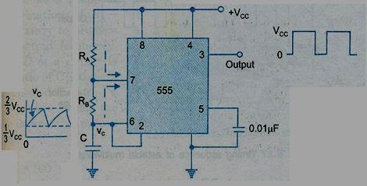

- When the capacitor voltage is just greater than ² ₃ V_{CC} the upper comparator triggers the upper flip-flop so that Q =1. This in turn, makes transistor Q₁ ON and capacitor C starts discharging towards ground through R_{B} and Q₁ with s time constant R_{B}C.


- Current also flows into the transistor Q₁ through R_{A}. Resistors R_{A} and R_{B} must be large enough to limit this current and prevent damage to the Q₁.
V

Ø The minimum value of R_{A} is approximately equal to ^{CC} _{0.2} , where 0.2 A is the current flowing through ON transistor Q₁
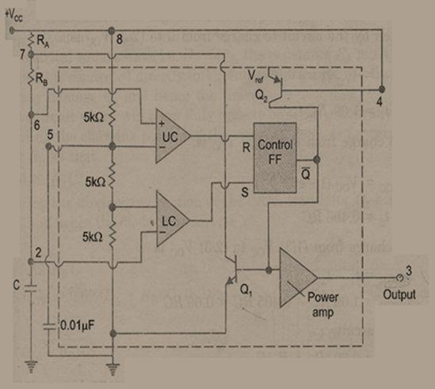

Fig: Functional diagram of astablemultivibrator using 555 timer.
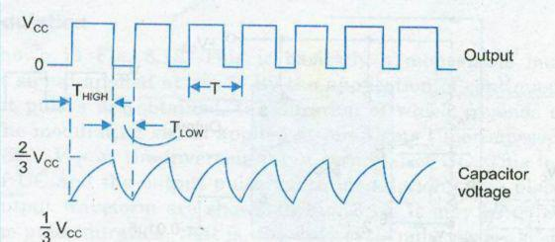

Fig: Timing sequence of astable multivibrator

- During the discharge of timing capacitor C, when its value is just less than ¹₃ V_{CC} , the lower comparator is triggered and at this stage S=1, R=0, which turns Q =0. Now

capacitor C is unclamped. Thus capacitor charges and discharges periodically between ² ₃ V_{CC} and ¹₃ V_{CC} .

- The length of the time that the output remains HIGH is the time for the capacitor to charge from ¹₃ V_{CC} to ² ₃ V_{CC} . It is calculated as follows:
- capacitor voltage for a low pass RC circuit subjected to a step input of V_{CC} is given by,

V _{C} = V _{CC} (1 - e ⁻ ^{t} / ^{RC} )

- The time taken by the circuit to charge from 0 to ² ₃ V_{CC} is

\²₃V_{CC} =V_{CC}(1-e^{-t}1/ ^{RC})

t₁ = 1.09 RC

and the time t₂ to charge from 0 to ¹₃ V_{CC} is,

\1 _{V} =_{V} (₁-_{e}^{-t}2 ^{/RC})

₃ CC CC

t₂ = 0.405 RC

Ø So the time to charge from ¹₃ V_{CC} to ² ₃ V_{CC} is,

T HIGH = t1 – t2

T _{HIGH} = 1.09 RC - 0.405 RC = 0.69RC So for the given circuit,

T _{HIGH} = 0.69(R_{A}+R_{B}) C

- The output is LOW while the capacitor discharges from ² ₃ V_{CC} to ¹₃ V_{CC} , and the voltage across the capacitor is given by,

\¹₃V_{CC} =²₃V_{CC}(e^{-t} / ^{RC})

Solving we get,

t = 0.69 RC

So for the given circuit,

T_{LOW} = 0.69R_{B}C

- Resistors R_{A} and R_{B} are in charging path and R_{B}is in discharging path. Therefore the total time is given by,

- = THIGH + TLOW

  - 0.69(R_{A}+R_{B}) C + 0.69R_{B}C

  - 0.69(R_{A}+2R_{B}) C

f = | 1 | = | 1.45
f = | T | = | (R_{A} + 2R_{B} )C
- The below figure shows the various combinations of (R_{A}+2R_{B}) and C necessary to produce the given time delay.

- The Duty cycle (D) of a circuit is defined as the ratio of ON time to the total time period, T = T_{ON} +T_{OFF} . Its expression is given as
D% = ^{TON} ´100

T
_{D%} ₌ ^{R}A ⁺ ^{R}B _{´100}

R_{A} + 2R_{B}

- Explain the operation of MonostableMultivibrator using 555 timer. (Nov/Dec-18) (April/May-17)(April/May-16)

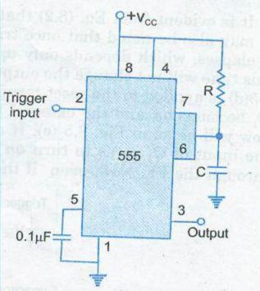

- The above figure shows 555 timer connected for monostable operation and its functional diagram is shown below.

- In the stable state, FF hold transistor Q₁ ON, thus clamping the external timing capacitor C to ground. The output remains LOW.

- As the trigger passes through (¹₃V_{CC} ), the FF is set, i.e. Q = 0 . This makes transistor Q₁ OFF and short circuit across the timing capacitor C is released.
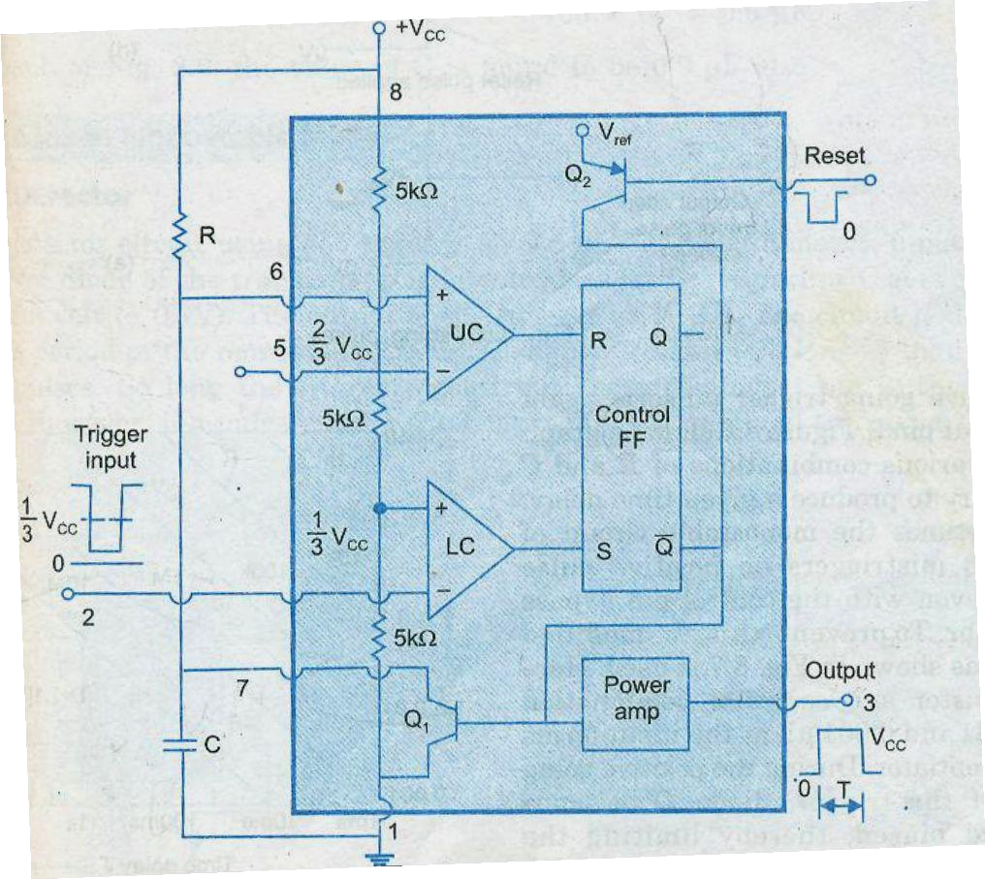
- As Q = 0 , output goes HIGH (=V_{CC}).Now the voltage across C rises exponentially through R towards V_{CC} with time constant RC.

Fig: Timer in monostable operation with functional diagram

- After a predefined time period T, the capacitor voltage is just greater than (²₃V_{CC} ) and the upper comparator resets the FF (R=1, S=0). This makes Q =1, and transistor Q₂ goes ON, thereby discharging the capacitor C rapidly to ground potential.

- The output returns to stable state. The voltage across the capacitor is given as,

 | V _{C} = V _{CC} (1 - e ⁻ ^{t} / ^{RC} )------------------ |  | (1)
At t =T, | V_{C} = (² | ₃V_{CC} )------------------ | (2)


Taking natural logarithm on both sides,

T = 1.1 R.C (Seconds)

- The timing interval is independent of the supply voltage. Also once triggered the output remains HIGH state until time T is completed, which depends only on R and C.

- Any additional trigger pulse coming during this time will not change the output state.

However if negative going reset pulse is applied to pin 4 during the timing cycle, the transistor Q₂ goes OFF, Q₁ becomes ON timing capacitor C is immediately discharged.

- Even if the reset is released the output remains LOW until a negative going trigger pulse is applied at input terminal pin 2.

- The below figure shows the various combinations of R and C necessary to produce the given time delay.
